
Dawood University Of Engineering and Technology Department of Computer Science
Phishing Attacks: A Demonstration Study
Syed Muhammad Shaharyar Email:muhammadshaharyar005@gmail.com
Abstract
Phishing attacks represent one of the most pervasive threats in modern cybersecurity, exploiting human vulnerabilities to obtain sensitive information. This study presents an educational demonstration of how phishing attacks are conducted using the open-source tool Zphisher in a controlled, professional environment. The paper covers an overview of phishing methodologies, a review of relevant literature, the tools and procedures employed, and the results observed. Findings indicate that users are highly susceptible to realistic fake login pages, underscoring the critical need for both technical countermeasures and user awareness training.
Keywords—phishing; cybersecurity; spear phishing; Zphisher; social engineering; user awareness.

I. INTRODUCTION
Phishing attacks are a common type of cyberattack in which an attacker attempts to trick individuals into revealing sensitive information. These attacks are usually carried out through different methods such as emails, messages, or social media links. In a typical phishing attack, the attacker creates a fake message or a fraudulent website that appears to be from a legitimate source and sends it to the victim.
When the target clicks on the provided link, they are redirected to a website that looks almost identical to a real and trusted site. This makes it very difficult for users to identify whether the website is genuine or fake. Once the victim enters sensitive information such as usernames, passwords, or financial details, the data is captured by the attacker and can be misused for malicious purposes.
Phishing attacks can take various forms, including email phishing, spear phishing, and others. Due to their deceptive nature and increasing sophistication, phishing attacks have become a serious threat to individuals and organizations, highlighting the need for awareness and effective security measures.
II. LITERATURE REVIEW
Phishing attacks have emerged as a prominent topic for study in the field of cybersecurity owing to their growing methodologies. Various studies have been conducted regarding phishing attacks using different approaches, namely attack methodology, detection technique, and victim’s behaviour. The early studies were centred on email-based phishing attacks, where attackers employed emails containing fraudulent content that prompted the user to visit malicious websites or download malicious files.
With the development of phishing methods, the idea of targeted attacks, like spear phishing, was developed by scholars. Unlike regular phishing, where a generic message is sent to many people, spear phishing entails the creation of a message crafted to target a specific person or organization.
Recently, the emphasis in studies has shifted to building automatic systems for detection based on machine learning and artificial intelligence. Several approaches including URL analysis, content filtering, and classification techniques have been suggested for recognizing phishing web pages and emails. However, no matter what advanced technology is developed, phishing continues to remain a persistent and serious threat.
Human aspects have also been highlighted in phishing attack research. Various studies indicate that ignorance on the part of users and lack of security measures are major contributing factors. Hence, cybersecurity experts advise the need to educate users on how to identify and deal with phishing scams.
Moreover, many studies emphasize the significance of using multilayer security solutions, such as Multi-Factor Authentication (MFA), secure web browsers, and anti-phishing email filters. A multilayered approach helps prevent phishing attacks more effectively. According to the current literature, the phishing threat is ever-changing; therefore, dealing with it requires a combination of sophisticated technologies and user education.
III. METHODOLOGY
A. Research Approach
This study demonstrates how a phishing attack performs in a professional environment. The objective is not to conduct an illegal or malicious attack, but rather to serve an educational purpose by illustrating how such attacks operate in practice.
B. Tools Used
The primary tool used in this study is Zphisher, an open-source phishing tool used to create phishing pages mimicking official companies such as Facebook, LinkedIn, Discord, Instagram, Google, Microsoft, and Netflix. The tool provides various configuration options to simulate realistic attack scenarios.
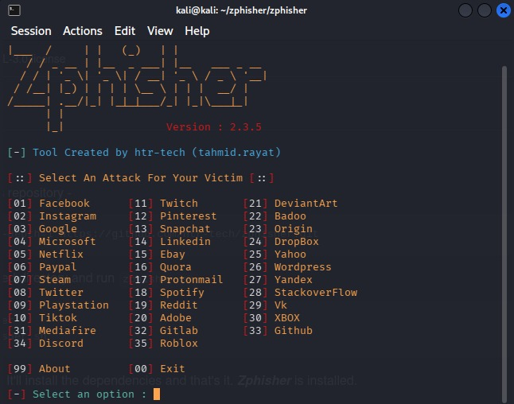
C. Procedure
Zphisher provides various options to create a fake login page. This fake login page is presented to test users who may not be able to distinguish it from a real site. In most observed cases, users did not identify the fraudulent page and proceeded to enter their sensitive information.
D. Data Collection
After the user enters sensitive information, the attacker’s system receives the data submitted by the user. In this educational demonstration, the data flow was monitored to document how submitted credentials are captured without the user’s awareness.
IV. RESULTS
After successfully generating the fake login page, a link was produced and sent to the target. Upon clicking the link, the target’s IP address was recorded at the back end. The page was visually indistinguishable from the legitimate website, making it highly difficult for the user to identify it as fraudulent.
Once the target entered their credentials (username and password) and clicked submit, the data was transmitted to the attacker’s system. The user remained unaware of the data exfiltration, typically attributing any anomaly to a server-side issue. This result confirms the effectiveness and danger of phishing attacks against unsuspecting users.
V. How to avoid it
The prevention of phishing attacks involves both awareness and technical solutions. Some ways of preventing phishing attacks are:
A. Verify URLs and Sender of Emails
It is important to ensure that you have checked the URL of the site before inputting your username and password. This is because phishing sites usually tend to use a different URL than the actual one; for example, "facebo0k.com" instead of "facebook.com". Likewise always be careful about the email address of the sender and check it carefully.
B. Enable Multi-Factor Authentication (MFA) MFA adds an extra layer of security by requiring a second form of verification beyond just a password. Even if credentials are stolen through phishing, the attacker cannot access the account without the second factor such as an OTP or authentication app.

C. Use Anti-Phishing Tools and Browser Extensions Modern browsers and security tools offer built-in phishing protection. Tools such as Google Safe Browsing, Microsoft Defender SmartScreen, and browser extensions like Netcraft can detect and block known phishing websites automatically.
D. Keep Software and Systems Updated Regularly updating operating systems, browsers, and antivirus software ensures that known vulnerabilities are patched, reducing the risk of being redirected to malicious sites through outdated software exploits.
E. User Awareness and Training As highlighted in the literature review, human ignorance is one of the biggest contributing factors to successful phishing attacks. Organizations should conduct regular cybersecurity awareness training to help users recognize phishing attempts, suspicious links, and social engineering tactics.
F. Use Email Filters Deploy spam and phishing filters on email servers to automatically detect and quarantine phishing emails before they reach the user's inbox. Most enterprise email solutions such as Microsoft 365 and Google Workspace include built-in anti-phishing filters.

VI. CONCLUSION
Phishing remains one of the most powerful forms of cybercrime, particularly effective against users with limited awareness of cybersecurity threats. This study demonstrates how phishing tools can be used to create realistic fake websites that deceive users into providing sensitive information. The results show that ordinary users can easily be tricked into submitting their credentials to unauthorized websites.
In conclusion, preventing phishing attacks requires a combination of technical solutions and user education to minimize risks in the digital environment. Future work should focus on developing more robust detection mechanisms and improving public awareness of evolving phishing strategies.
VII. REFERENCES
[1] A. K. Jain and B. B. Gupta, “A novel approach to protect against phishing attacks at client side using auto-updated white-list,” EURASIP J. Inf. Secur., vol. 2016, no. 1, pp. 1–11, 2016.
[2] R. Heartfield and G. Loukas, “A taxonomy of attacks and a survey of defence mechanisms for semantic social engineering attacks,” ACM Comput. Surv., vol. 48, no. 3, pp. 1–39, 2016.
[3] I. Fette, N. Sadeh, and A. Tomasic, “Learning to detect phishing emails,” in Proc. 16th Int. Conf. World Wide Web (WWW), 2007, pp. 649–656.
[4] S. Abu-Nimeh, D. Nappa, X. Wang, and S. Nair, “A comparison of machine learning techniques for phishing detection,” in Proc. Anti-Phishing Working Groups 2nd eCrime Researchers Summit, 2007, pp. 60–69.
[5] Zphisher, “Zphisher: Advanced phishing tool,” GitHub repository. [Online]. Available: https://github.com/htr-tech/zphisher. [Accessed: 2024].
[6] Raja jabir, John le, Chau Nguyen, “Phishing Attacks in the Age of Generative Artificial Intelligence: A Systematic Review of Human Factors”
[7] Ruth Johnson from Old Dorminion University “2025 Cyber Security Research project showcase”
[8] Tariq Saeed, Muhammad Nafees, from Iqra University,” A Systematic Literature Review on Phishing Attacks and Countermeasures”
[9] Rajish Tanti from OP Jindal University, Raigarh , Chhattisgarh,” Phishing Attack: A Case Study and their Prevention Techniques” October 2024
[10] Zainab Alkhalil, Chaminda Hewage *, Liqaa Nawaf and Imtiaz Khan from Cardiff School of Technologies, Cardiff Metropolitan University, Cardiff, United Kingdom,” Phishing attack: A Recent Comprehensive Study and a new anatomy” 9 march 2021.

